**OLR 0.5 T63 MONEY**

A long time ago, people traded for what they wanted. Perhaps one person had a wonderful spear made of stone and wood, and another had a beautiful necklace made of stones and shells. **Each** wanted what the other had. To solve this, they traded. This is

**5** called barter.

**Different Kinds of Money:**

Sometimes, it was difficult for people to put a barter price on things, so people began to use money as a form of payment.

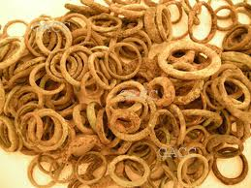In the beginning, things were not very consistent.

**10** The Aztecs used small doll figures to buy things. These were made of gold.

The ancient Egyptians used ring money. Ring money was an actual ring made of bronze, copper or gold. In ancient Egypt, people liked to wear their wealth. When they had to pay for

something, they simply pulled off a ring or two to use as payment.

The Celts in ancient Ireland also used ring money, but they also used bracelet money. The Celts also liked to wear their wealth.

In other places in the world, people tried to use rice, bread, salt or chocolate as

money, but **that** did not work very well. The food went bad, or it was eaten. People

soon learned that although many things would work as money, to be useful, the item they used as money had to follow some simple rules. Others should also accept **it** as money. It had to have an assigned value. It had to be easy to carry – it had to be made of a strong material, something that could be handed from person to person easily.

**Coins:**

Ancient Turkey. About 2,700 years ago, somebody came up with the idea of using

metal coins as money. Everybody loved **this new idea**. The first coins appeared in the kingdom of Lydia, a little coastal kingdom on the Aegean Sea. They were round and flat and made of gold and silver. They were also small and easy to carry. They were

decorated with pictures and designs. The use of coins made trade simple.

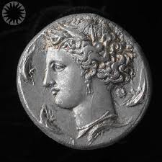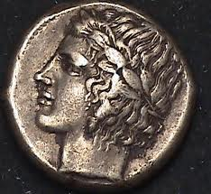Ancient Greece. The idea of metal money became

popular rapidly. About 2,500 years ago, each Greek city-state started to make **its** own coins. Each Greek city-state had banks where visiting

traders could exchange their coins for Greek coins. Then, **they** used **them** to buy and sell in the

great Greek marketplaces.

Coins were not used only as money. In ancient Greece, people believed that they had magical powers. The Greeks designed their coins with pictures of their gods and

goddesses. The Greeks were the first civilization to use pictures of real people on their coins. **The first** was Alexander the Great.

Ancient Rome. The ancient Romans thought the use of coins was really clever. They copied the idea. At first, the Romans put pictures of gods and goddesses on their coins, an idea they borrowed from the ancient Greeks. Soon, they began to put

pictures of buildings on their coins. They were the first to add symbols like stars and eagles on their coins. Some of their coins pictured current emperors. The purpose of

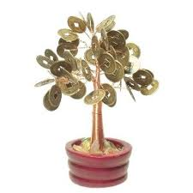 this was to make an emperor popular.

Ancient India. In ancient India, people used money trees to store their coins. A money tree was a flat piece of metal, shaped like a

tree, with metal branches. At the end of each branch was a round disk with a hole in the center. Each of these disks was an ancient

Indian coin. When you needed money, you simply broke off a coin from your money tree. The ancient Indians often used pictures of dragons and other mythical animals on their coins.

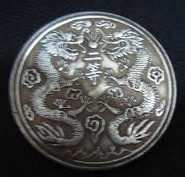Ancient China. Ancient Chinese coins also had holes in the center. The coins were strung together on a string or rope. This was called

a string of cash. Like the ancient Indians, the ancient Chinese also decorated their coins with pictures of mythical creatures. They believed that coins brought luck. Coins were a popular present as

they provided wealth and luck.

**PART A. Read the following statements, and write the name(s) of the ancient civilizations in the blanks provided. Number 1 has been done for you.**

1. As a form of payment, they used bracelet money. _**The ancient Celts**_

2. Their coins had a hole in the center. _THE ANCIENT INDIA___________

3. The first coins were made by them. __THE ANCIENT GREECE______________

4. There were mythical creatures on their coins. __THE ANCIENT INDIA____________

5. They used doll figures made of gold. THE ANCIENT AZTECS_______________

6. They had pictures of stars on their coins. ________________

7. Their coins had pictures of their gods and goddesses on them. _THE ANCIENT TURKEY_______________

8. They believed that coins had the power of magic. __THE ANCIENT EGYPTIANS______________

**PART B. What do the following refer to?**

1. Line 3, **‘Each’** means Each **_____PEOPLE_________________**

2. Line 18, **‘that’** means **______________________**

3. Line 20, **‘it’** means **______________________**

4. Line 25, **‘this new idea’** means the idea of **______________________**

5. Line 31, **‘its’** means **______________________**

6. Line 34, **‘they’** means **______________________**

7. Line 34, **‘them’** means **______________________**

8. Line 39, **‘The first’** means the first of **______________________**

**PART C. Read the text again and answer the questions with complete sentences.**

1. What were the similarities between the ancient Egyptians and the ancient Celts?

____________________________________________________________

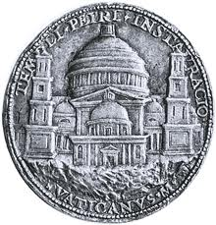2. According to the information given in the text, the following is an ancient ___________________________ metal coin.

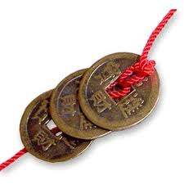3. According to the information given in the text, the following are ancient coins from _________________________.

4. Write three disadvantages of using food as a form of payment.

____________________________________________________________

5. Why did the ancient Romans put pictures of their current emperors on their coins?

____________________________________________________________

6. Where did people in ancient India keep their coins?

____________________________________________________________

7. Why did the ancient Chinese give coins as a present?

____________________________________________________________